Hi,

I hope your having a pleasant day!!!

I am a passionate Sr. Big Data Engineer with 8+ Years of IT industry experience along with a Master Degree.

Expertise in building the highly sophisticated systems in Analytics, Big Data space and Data warehousing.

Proficient in Hadoop, Spark, Scala, Python, Kafka, HBase, Hive, Sqoop, Oozie, Machine Learning models, traditional ETL/ELT (PDI, Data Stage and Teradata GCFR).

I am interested in a career in Information Technology industry and I would be interested in learning more about available opportunities.

My CV, which is enclosed, contains additional information on my experience and skills.

I would be thrilled to have the opportunity to visit you or have a call to present my background further. I can be reached anytime via my telephone, 60186698370 or via email at cj.shans@gmail.com.

Thank you for your time and consideration. I am looking forward to hearing from you.

Thanks,

Chiranjeevi

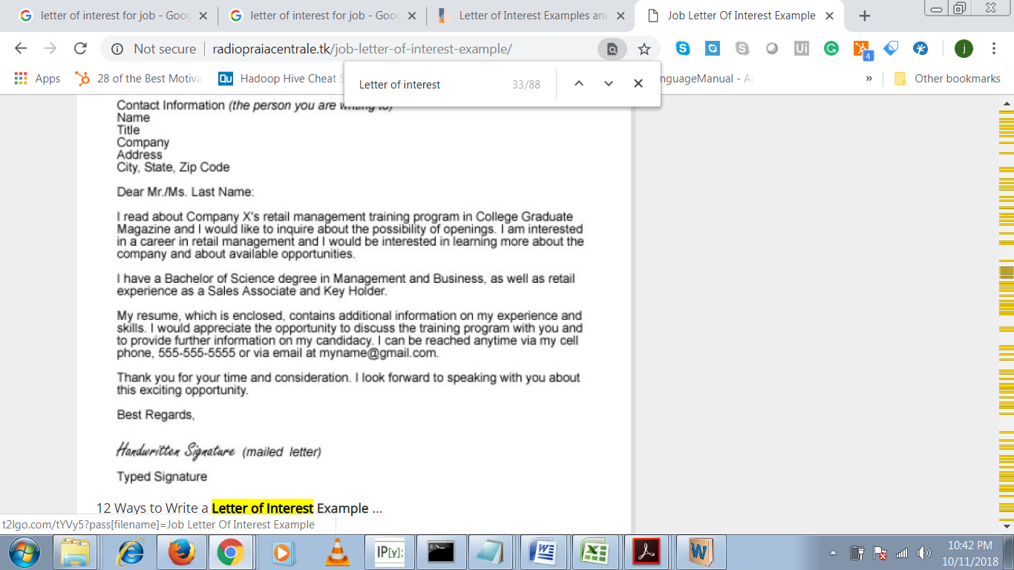

<http://radiopraiacentrale.tk/job-letter-of-interest-example/>